Worksheet “Who are allied soldiers and what they do in Estonia?"
Security and safety in Estonia relies on cooperation and partnerships with our allies. The purpose of the battle groups stationed in Estonia is to demonstrate solidarity, to strengthen Estonia’s independent defence capability and keep the peace. In today’s e-lesson you will learn who are allied soldiers and what they do in Estonia.

Use the worksheet as follows:
- Answer the question before the live stream
- Ask questions during live stream
- After the live stream have a discussion with your classmates and complete the exercise.

BEFORE THE LIVE STREAM

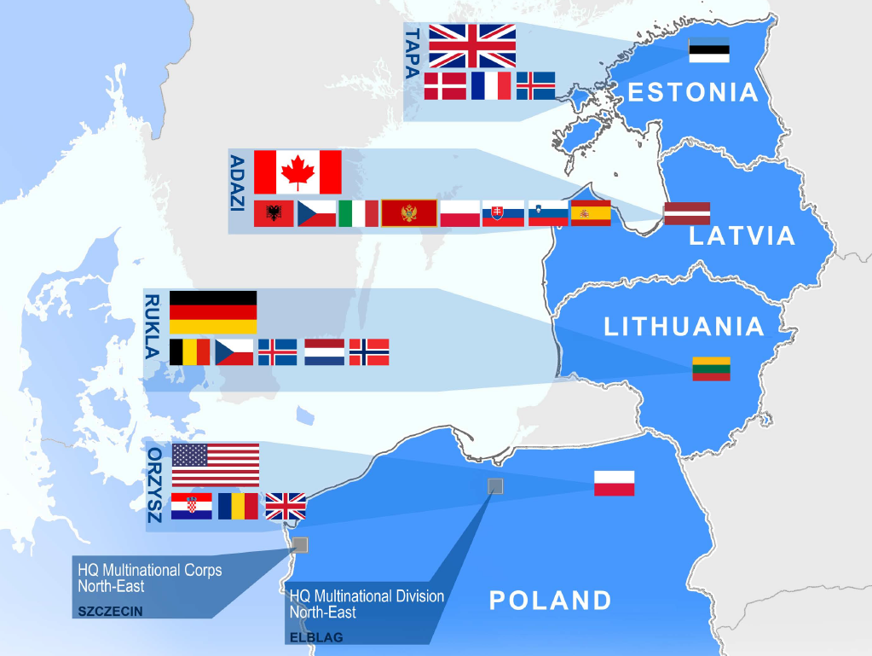
Source:https://www.kaitseministeerium.ee/en/allied-forces-estonia

Look at the illustrated map above. This map represents allied countries that have decided to deploy their units in Baltic countries and Poland. How well do you know the flags of these countries? With the help of the internet fill the following table showing which countries are being deployed in the Baltic countries to strengthen Estonia’s independent defence capability.

Countries
Estonia (4)
Latvia (9)
Lithuania (6)

DURING THE LIVE STREAM

You have a chance to ask questions from the guest lecturer during the live stream. To do so add your question to Youtube chat as follows:

Kaari 12. Form, Kurtna School. How do you become a president?

Please be polite and precise while forming your question. Your questions are visible to everyone watching the live stream. The sooner you get to send your question, the more likely we are able to answer it.

AFTER THE LIVE STREAM WRITE A LETTER

Using the RAFT* creative writing system, write a creative letter using the new information and knowledge you learnt in today’s lesson about allied soldiers in Estonia. You can choose
- your own role
- whom the letter is addressed to
- what format does the letter have
- what topic does the letter cover

Mark your choices with a “x” in the table.

For example: You are an Estonian soldier performing in the 24th of February parade, giving a speech about training with allied forces.

RAFT table
* RAFT: Choose one option from each column, they don’t have to be all in the same in a row.

Role | Audience | Form | Topic
British soldier in Tapa | Your family | Letter | Reasons why we need allied soldiers in Estonia
Estonian soldier n Tapa | Best friend | Speech | Everyday life for a soldier in Tapa
Estonian prime minister | 24th of February parade | Diary entry (in that case you don’t need to choose an audience) | Training with allied soldiers

Write here:

